**FINAL PROJECT- BAYESIAN STATISTICS (MA5770)**

**NAME:** Manoj Kumar Surabhi

**PROJECT TITLE:** Bayesian Mixture Normal Model of Plasma Glucose Data

**SECTION-1: INTRODUCTION**

This project investigates the application of Bayesian statistical methods within a simulated framework. The main aim is to implement a Gibbs sampler using both manual and automated (JAGS) approaches and evaluate the performance of each model using MCMC diagnostics.

**SECTION-2: STATISTICAL ANALYSIS**

Gibbs sampling and JAGS will be used to approximate the posterior distribution of the mixture normal model. The MCMC diagnostics, including trace plots, autocorrelation, posterior means, posterior quantiles, and effective sample sizes, will assess the convergence and efficiency of the sampling process. The software packages used for this project are R and JAGS.

The histogram and density plot in Figure 1 display the plasma glucose levels of 532 women. The data shows a right-skewed distribution. The sample mean is 121.0, the median is 115, and the mode is approximately 100. This suggests that a normal distribution may not be suitable for modeling the data.

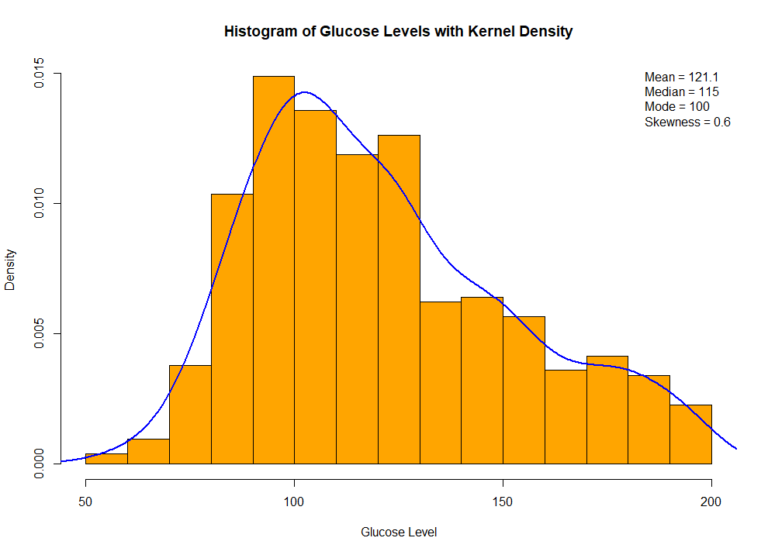

Figure 1: Histogram and density of the data

**SECTION 3: STATISTICAL MODEL**

From Figure 1, we can see that the data is right-skewed, and using a normal model might not adequately capture its characteristics. Therefore, we are using a mixture normal model, which accounts for multiple groups within the data, providing better flexibility and a more accurate fit to the observed distribution.

The mixture normal model is used to classify observations into two groups using latent variables(Xi), a mixing proportion (π), and group-specific parameters (θ1, $σ_{1}^{2}$, and θ2, $σ_{2}^{2}$ ​).

**Sampling distributions:**

For each observation Yi, the model assumes a mixture of two normal distributions based on the latent variable Xi:

$$Y_{i}| X_{i}=dNormal\left(θ_{k}, σ_{k}^{2}\right), k∈\{1,2\}$$

The latent group membership Xi follows:

$$P\left(X_{i}=1\right)=π, P\left(X_{i}=2\right)=1-π.$$

**Prior Distributions:**

The priors for the parameters are independent:

Mixing Proportion (π):

P(π)∼dBeta(α,β).

Group Means (θ1, θ2 ​):

$$θₖ ∼ N\left(μ^{0}, τ^{02}\right), k = 1, 2.$$

Group Variances ($σ_{1}^{2}, σ_{2}^{2}$ ​):

**P ($σₖ^{2})= Inverse-Gamma\left(\frac{ν_{0}}{2},\frac{ν_{0} σ_{0}^{2}}{2}\right), k = 1, 2.$**

**Full Conditional distributions:**

Based on the prior and sampling distributions, we can use the below conditional distributions for the Gibbs sampler.

$P\left(Xᵢ = k ∣ π, θ^{1}, θ^{2}, σ_{1}^{2}, σ_{2}^{2}, Yᵢ = yᵢ\right)∝ πₖ * N\left(yᵢ; θₖ, σₖ^{2}\right)$ is the conditional probability of Xi = k.

where:

π1=π, π2=1−π, k=1,2.

$π∣X1​,…,Xn​∼dBeta\left(α+n_{1​},β+n_{2​}\right)$ is the mixing proportion of **π**

where,

n1 = number of observations in group 1( Xi = 1)

n2 = n – n1: Number of observations in group 2

**Group Means (θ1, θ2​):**

**For k=1,2,** the conditional distribution of the means are:

The conditional posterior distribution of the mean for group 1 is:

$P(θ₁ | yᵢ, X, π, θ₂, σ₁², σ₂²)= dnorm\left(θ₁;\frac{\left[\left(\frac{1}{τ₀²}\right)μ₀+ \left(\frac{n₁}{σ₁²}\right)ȳᵢ\right]}{\left[\left(\frac{n₁}{σ₁²}\right)+ \left(\frac{1}{τ^{02}}\right)\right]}, \frac{1}{\left[\left(\frac{n₁}{σ₁²}\right)+ \left(\frac{1}{τ₀²}\right)\right]}\right)$

Where,

n1 = number of observations in group 1 (xi = 1)

**τ0^2**​: Prior variance for θ1​ and θ2 ​.

μ0​: Prior mean for θ1 and θ2.

Yi bar = ∑i:xi ​yi : Sum of squared deviations of observations in group k from their group mean θk​.

The conditional posterior distribution of the mean for group 2 is: $P(θ_{2} | yᵢ, X, π,θ₁, σ₁², σ₂²)= dnorm\left(θ_{2};\frac{\left[\left(\frac{1}{τ₀²}\right)μ^{0}+ \left(\frac{n_{2}}{σ_{2}^{2}}\right)ȳᵢ\right]}{\left[\left(\frac{n_{2}}{σ_{2}^{2}}\right)+ \left(\frac{1}{τ₀²}\right)\right]}, \frac{1}{\left[\left(\frac{n_{2}}{σ_{2}^{2}}\right)+ \left(\frac{1}{τ₀²}\right)\right]}\right)$

Where,

n2 = Number of observations in group 2 (xi=2), where n2=n−n1​.

σ^2​: Scale parameter for the Inverse-Gamma prior on σ1^2 and σ2^2​ .

**Group Variances** ($σ_{1}^{2}, σ_{2}^{2}$ ​)**:**

The conditional posterior distribution of the variance for group 1 is:

$$p(σ₁² | θ₁, θ₂, σ₂², π y, x )$$

$$= Inverse-Gamma\left(\frac{n_{1}+ {ν0}^{}}{2},\frac{{S_{1}}^{2}+ {ν0}^{}{σ0}^{2}}{2}\right)$$

Where,

n1 = number of observations in group 1 (xi = 1)

θ1 ​:Mean of group 1.

The conditional posterior distribution of the variance for group 2 is:

$$p(σ₂²| θ₁, θ₂,σ₁² , π y, x )$$

$$= Inverse-Gamma\left(\frac{n_{2}+ ν_{0}}{2},\frac{{S_{2}}^{2}+ ν_{0} {σ_{0}}^{2}}{2}\right)$$

Where,

n2= number of observations in group 2 (xi = 2)

θ2 ​: Mean of group 2.

$ν_{0}$ ​: Shape parameter for the Inverse-Gamma prior on σ1^2 and σ2^2​.

${σ_{0}}^{2}$: Scale parameter for the Inverse-Gamma prior on σ1^2 and σ2^2​.

**SECTION-4: GIBBS SAMPLER**

It is difficult to directly obtain the posterior distribution of $x1​,…,xn​,π,θ1​,θ2​,σ_{1}^{2​},σ_{2}^{2​},$ so the Gibbs sampler is implemented to sample this posterior distribution:

1. **Initialization:**

* Set the hyperparameters: $α=1,β=1,μ_{0​}=120,τ_{02​}=200,ν_{0​}=10,σ_{0}^{2​}=1000.$
* Latent variables $x_{i}^{0}$:

For chain 1:

$$x_{i}^{0}= \{_{2 otherwise}^{1 if y_{i}<median(y_{1},….,y_{n})}$$

For chain 2:

$$x_{i}^{\left(0\right)​}∼Bernoulli\left(0.5\right).$$

* Initial variances: For both chains, initialize $σ_{1}^{2}, σ_{2}^{2}$ as the sample variances of $y_{1},…, y_{n}$ for the respective groups determined by $x_{i}^{0}.$

1. **Gibbs Sampling:**

* Sample $π^{s}:$ $π^{s}∼Beta\left(α+n_{1}^{\left(s-1\right)​},β+n_{2}^{\left(s-1\right)​}\right)$, where $n_{1}^{\left(s-1\right)​}$ and $n_{2}^{\left(s-1\right)​}$ ​ are the number of observations in groups 1 and 2, respectively, at iteration s−1.
* Sample $θ_{1}^{\left(s\right)​}and θ_{2}^{s}$: $θ_{k}^{\left(s\right)​}∼Normal\left(μ_{k​},σ_{k}^{2​}\right),$

Where,

$$​μ_{k​}= \frac{\frac{μ_{0}}{τ_{0}^{2}}+ \sum_{i∈\left\{xi\left(s-1\right)​=k\right\}}{\frac{y_{i}}{{\left(σ_{k}^{2}\right)}^{s-1}}}}{\frac{1}{τ_{0}^{2}}+\frac{n_{k}^{s-1}}{{\left(σ_{k}^{2}\right)}^{s-1}}}​$$

* Sample